【Course presentation 互動式簡報】
*名稱： | 建立互動式簡報
說明：
□顯示說明
最高等級： | 10
編輯器： | Course presentation 互動式簡報
 | Tutorial 指南 Example 範例
 | 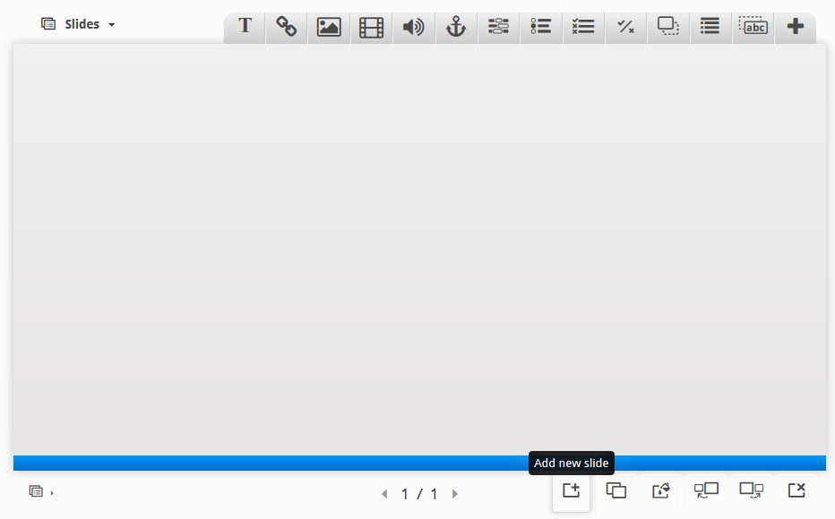
 | ▼Behavioural settings 行為設定
□ Activate Active Surface Mode 簡報播放模式設定
Removes navigation controls for the end user. Use Go To Slide to navigate. 取消提供操作功能列給使用者。使用＂播放簡報＂方式進行內容揭露
□ Hide Summary Slide 隱藏總結頁簡報
Hides the summary slide. 隱藏總結頁簡報
 |  | Override "Show Solution" button “查看解法”功能鈕 |  | This option determines if the "Show Solution" button will be shown for all questions, disabled for all or configured for each question individually. 設定所有問題是否顯示”查看解法”功能鈕，全部啟用或是禁用
-
(- 無、Enabled 啟用、Disabled 禁用)
 |  | Override "Retry" button “重試”功能鈕 |  | This option determines if the "Retry" button will be shown for all questions, disabled for all or configured for each question individually. 設定所有問題是否顯示”重試”功能鈕，全部啟用或是禁用
-
(- 無、Enabled 啟用、Disabled 禁用)
□ Enable print button 啟用列印功能鈕
Enables the print button. 啟動列印功能鈕
 |  | ▼Social Settings 社群分享設定
 |  |  |  |  | ☑ Display Facebook share icon 顯示Facebook分享圖示
 |  |  |  |  | ▼Facebook share settings: @currentpageurl Facebook分享設定
 |  |  |  |  |  | Share to Facebook link 分享到Facebook(連結) |  | @currentpageurl
 |  |  |  |  |  | Share to Facebook quote 分享到Facebook(引用) |  | I scored @percentage on a task at @currentpageurl.
 |  |  |  |  | □ Display Twitter share icon 顯示Twitter分享圖示
 |  |  |  |  | □ Display Google+ share icon 顯示Google+分享圖示
▼Text overrides and translations 優先顯示文字及翻譯
Here you can edit settings or translate texts used in this content. 您可在此編輯或設定翻譯文字
 |  | ▼Localize: Slide 在地化：簡報
 |  |  | Translation for "Slide" * 簡報標題 |  |  |  | Slide 簡報
 |  |  | Translation for "Your Score" * 你的分數 |  |  |  | Your Score 你的分數
 |  |  | Translation for "Max Score" * 最高分數 |  |  |  | Max Score 最高分數
 |  |  | Greeting given for GOOD score * 好成績的問候語 |  |  |  | @percent is replaced by the real user score in percent @percent 以真實使用者百分比分數取代
 |  |  |  |  |  |  | Congratulations! You got @percent correct!
 |  |  | Greeting given for OK score * 一般成績的問候語 |  |  |  | @percent is replaced by the real user score in percent @percent 以真實使用者百分比分數取代
 |  |  |  |  |  |  | Nice effort! You got @percent correct!
 |  |  | Greeting given for BAD score * 不好成績的問候語 |  |  |  | @percent is replaced by the real user score in percent @percent 以真實使用者百分比分數取代
 |  |  |  |  |  |  | You got @percent correct.
 |  |  | Translation for "Total" * 總分標題 |  |  |  | TOTAL 總分
 |  |  | Title for show solutions button * 查看解法功能鈕名稱 |  |  |  | Show solutions 查看解法
 |  |  | Text for the retry button 重試功能鈕名稱 |  |  |  | Retry 重試
 |  |  | Translation for "Title" * 標題名稱 |  |  |  | Title 標題
 |  |  | Translation for "Author/supplier" * 作者/供應商 |  |  |  | Author 作者
 |  |  | Translation for "License" * 授權資訊 |  |  |  | License 授權資訊
 |  |  | Text for the export text button * 匯出功能鈕名稱 |  |  |  | Export text 匯出
 |  |  | Text for the "Rights of use" button * 顯示＂使用權＂功能鈕名稱 |  |  |  | Rights of use 使用權
 |  |  | Hide keywords list button title * 隱藏關鍵字列表功能鈕名稱 |  |  |  | Hide keywords list 隱藏關鍵字列表
 |  |  | Show keywords list button title * 顯示關鍵字列表功能鈕名稱 |  |  |  | Show keywords list 顯示關鍵字列表
 |  |  | Fullscreen label * 全螢幕標題 |  |  |  | Fullscreen 全螢幕
 |  |  | Exit fullscreen label * 關閉全螢幕標題 |  |  |  | Exit fullscreen 退出全螢幕
 |  |  | Previous slide label * 前一張簡報名稱 |  |  |  | Previous slide 前一張簡報
 |  |  | Next slide label * 下一張簡報名稱 |  |  |  | Next slide 下一張簡報
 |  |  | Current slide labe * 目前簡報名稱 |  |  |  | Current slide 目前簡報
 |  |  | Last slide label * 上一張簡報名稱 |  |  |  | Last slide 上一張簡報
 |  |  | Exit solution mode text * 退出查看解法模式名稱 |  |  |  | Exit solution mode 退出查看解法模式
 |  |  | Solution mode text * 解法模式名稱 |  |  |  | Solution Mode 解法模式
 |  |  | Text when multiple tasks on a page * 單頁多組任務名稱 |  |  |  | Multiple tasks 多組任務
 |  |  | Score message text * 評分資訊名稱 |  |  |  | You achieved: 你達到了:
 |  |  | Share to Facebook text * 分享到Facebook |  |  |  | Share on Facebook 分享到Facebook
 |  |  | Share to Twitter text * 分享到Twitter |  |  |  | Share on Twitter 分享到Twitter
 |  |  | Share to Google text * 分享到Google+ |  |  |  | Share on Google+ 分享到Google+
 |  |  | Title for summary slide * 總結簡報頁標題 |  |  |  | Summary 總結
 |  |  | Title for the comments icon * 評論功能鈕名稱 |  |  |  | Show comments 顯示評論
 |  |  | Title for print button * 列印功能鈕名稱 |  |  |  | Print 列印
 |  |  | Print dialog ingress * 列印對話視窗 |  |  |  | How would you like to print this presentation? 你預計如何列印此份簡報?
 |  |  | Label for "Print all slides" button * ＂列印所有簡報頁＂功能鈕名稱 |  |  |  | Print all slides 列印所有簡報頁
 |  |  | Label for "Print current slide" button * ＂列印當前簡報頁＂功能鈕名稱 |  |  |  | Print current slide 列印當前簡報頁
 |  |  | Label for slides without a title * 沒有標題的簡報標題名稱 |  |  |  | No title 無標題
 |  |  | Explanation of slide navigation for assistive technologies * 簡報快速鍵說明 |  |  |  | Use left and right arrow to change slide in that direction whenever canvas is selected. 可使用左右箭頭來切換簡報頁
 |  |  | Canvas label for assistive technologies * 輔助操作說明 |  |  |  | Presentation canvas. Use left and right arrow to move between slides. 簡報播放時可使用左右箭頭來切換簡報頁
 |  |  | Label for uncompleted interactions * 未完成互動的簡報頁名稱 |  |  |  | @slideName contains not completed interaction @slideName 包含未完成的互動
 |  |  | Label for completed interactions * 已完成互動的簡報頁名稱 |  |  |  | @slideName contains completed interaction @slideName 包含完成的互動
 |  |  | Label for slide counter. Variables are @index, @total * 簡報頁數顯示名稱 |  |  |  | Slide @index of @total
 |  |  | Label for slides that only contains correct answers * 正確作答的簡報標示 |  |  |  | @slideName only has correct answers
 |  |  | Label for slides that has incorrect answers * 錯誤作答的簡報標示 |  |  |  | @slideName has incorrect answers

範例
1 | Image、 Text | 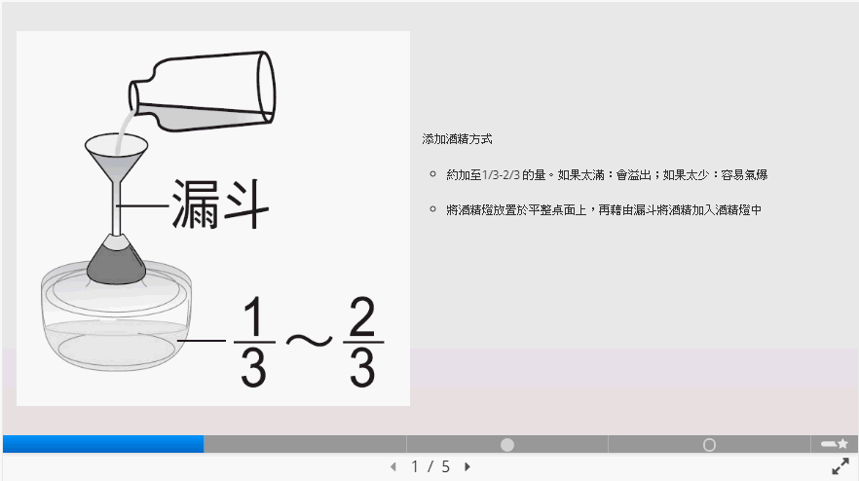 | 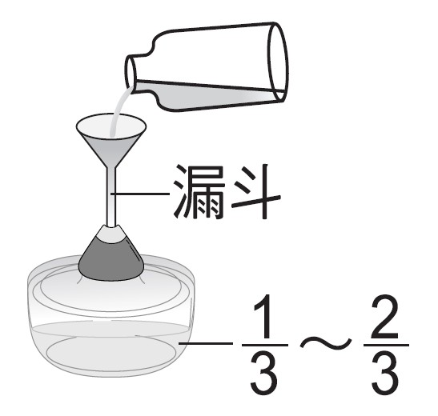  添加酒精方式  - 約加至1/3-2/3 的量。如果太滿：會溢出；如果太少：容易氣爆  - 將酒精燈放置於平整桌面上，再藉由漏斗將酒精加入酒精燈中
2 | Image、 Text | 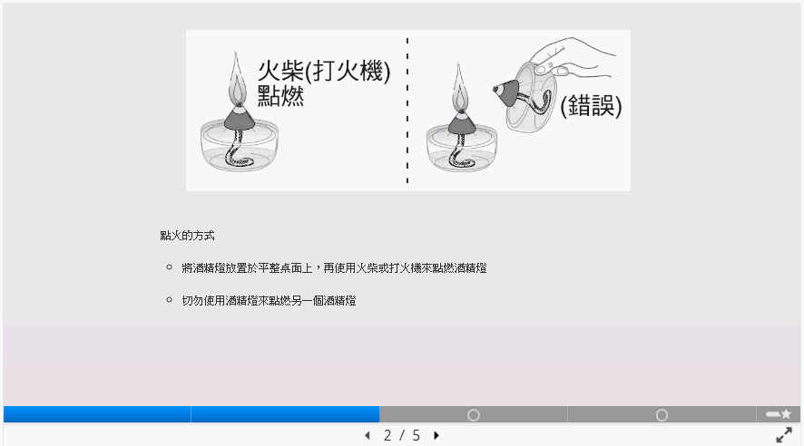 | 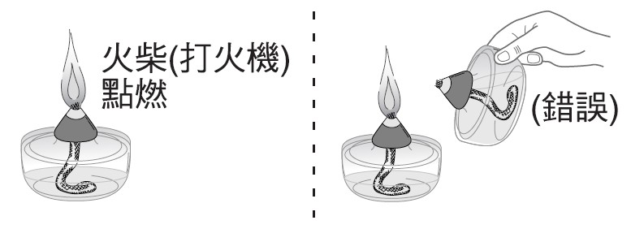  點火的方式  - 將酒精燈放置於平整桌面上，再使用火柴或打火機來點燃酒精燈。  - 切勿使用酒精燈來點燃另一個酒精燈
3 | Multiple Choice | 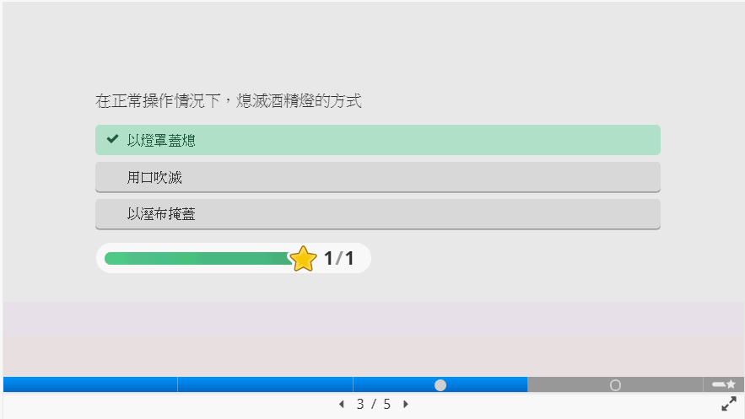 | 在正常操作情況下，熄滅酒精燈的方式  - 以燈罩蓋熄 (correct)  - 以溼布掩蓋  - 用口吹滅
4 | Drag and drop | 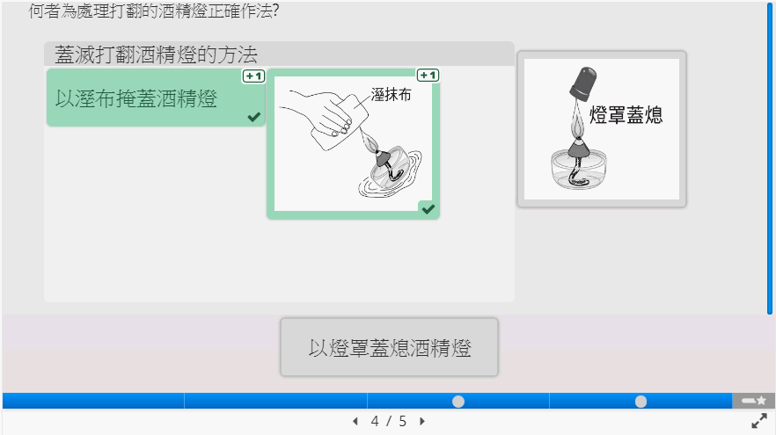 | 何者為處理打翻的酒精燈正確作法?  蓋滅打翻酒精燈的方法  - 以溼布掩蓋酒精燈 (correct)  - 以燈罩蓋熄酒精燈  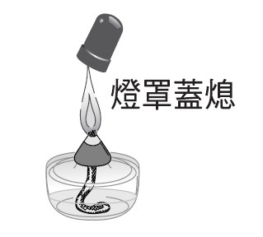  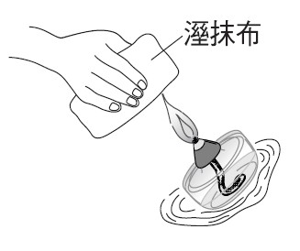  - 以溼布掩蓋酒精燈(圖示) (correct)  - 以燈罩蓋熄酒精燈(圖示)

